**Interesting Visualization:**

**Social Strategy using hashtags:**

When it comes to hashtags, companies should be able to track their hashtag use. Knowing which hashtags are popular on which days, they can drive people to find their content and get them talking which is essential to their social strategy.

I am using the metrics below for this visualization:

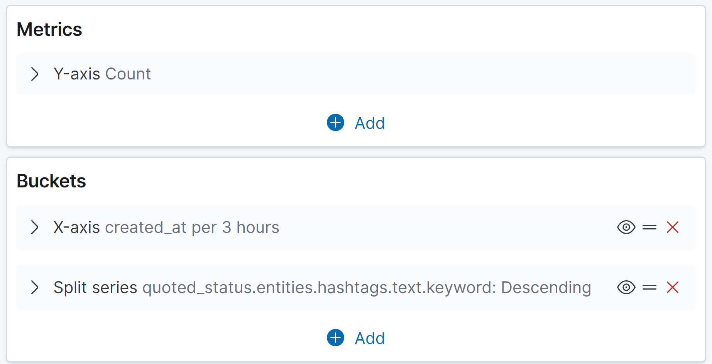

The visualization is as below:

This visualization shows the frequncy of different hashtags on different days. We can see what people are talking more about by considering these hashtags. For example:

The green color is highly visible on 2017.4.22 date. When we check it, we can see that this color belongs to Earth day hashtag.

Companies can use this kind of visualization to see what people are talking about on special days or even hours.